**EXPERIMENT-7:**

7)Develop a simple containerized application using Docker

* **Creating our own docker images**

**root@ip-172-31-93-101:/home/ubuntu# mkdir DockerImages**

**root@ip-172-31-93-101:/home/ubuntu# cd DockerImages**

**root@ip-172-31-93-101:/home/ubuntu/DockerImages# mkdir MyFirstImage**

**root@ip-172-31-93-101:/home/ubuntu/DockerImages# cd MyFirstImage**

* **Edit docker file**

**root@ip-172-31-93-101:/home/ubuntu/DockerImages/MyFirstImage#cat> Dockerfile**

FROM ubuntu:24.04

RUN apt update -y && apt install apache2 -y

CMD ["echo","Hello World Welcome to SaiSpurthi"]

* **Build & Run**

**root@ip-172-31-93-101:/home/ubuntu/DockerImages/MyFirstImage# docker build -t myfirst:0.1 .**

[+] Building 22.0s (6/6) FINISHED docker:default

=> [internal] load build definition from Dockerfile 0.0s

=> => transferring dockerfile: 148B 0.0s

=> [internal] load metadata for docker.io/library/ubuntu:24.04 0.5s

=> [internal] load .dockerignore 0.0s

=> => transferring context: 2B 0.0s

=> [1/2] FROM docker.io/library/ubuntu:24.04@sha256:278628f08d4979fb9af9ead44277dbc9c92c2465922310916ad0c46ec9 2.1s

=> => resolve docker.io/library/ubuntu:24.04@sha256:278628f08d4979fb9af9ead44277dbc9c92c2465922310916ad0c46ec9 0.0s

=> => sha256:278628f08d4979fb9af9ead44277dbc9c92c2465922310916ad0c46ec9999295 6.69kB / 6.69kB 0.0s

=> => sha256:f470988096c4d77efac9740a1b6700823681af518a17fad30111430b95dfbffa 424B / 424B 0.0s

=> => sha256:fec8bfd95b54439b934c5033dc62d79b946291c327814f2d4df181e1d7536806 2.30kB / 2.30kB 0.0s

=> => sha256:afad30e59d72d5c8df4023014c983e457f21818971775c4224163595ec20b69f 29.75MB / 29.75MB 0.5s

=> => extracting sha256:afad30e59d72d5c8df4023014c983e457f21818971775c4224163595ec20b69f 1.5s

=> [2/2] RUN apt update -y && apt install apache2 -y 17.9s

=> exporting to image 1.3s

=> => exporting layers 1.2s

=> => writing image sha256:f780930ac20f3b869bfbe93a8af0d715d8bbe77d137fa3a5beea02d8aa426db4 0.0s

=> => naming to docker.io/library/myfirst:0.1

**root@ip-172-31-93-101:/home/ubuntu/DockerImages/MyFirstImage# docker images**

REPOSITORY TAG IMAGE ID CREATED SIZE

myfirst 0.1 f780930ac20f 4 minutes ago 228MB

nginx latest 60c8a892f36f 7 weeks ago 192MB

hello-world latest d2c94e258dcb 18 months ago 13.3kB

jenkins 1.651.3 d5c0410b1b44 8 years ago 737MB

**root@ip-172-31-93-101:/home/ubuntu/DockerImages/MyFirstImage#docker run myfirst:0.1**

Hello World Welcome to SaiSpurthi

* **Building the second version**

**root@ip-172-31-93-101:/home/ubuntu/DockerImages/MyFirstImage# vi Dockerfile**

**root@ip-172-31-93-101:/home/ubuntu/DockerImages/MyFirstImage# cat Dockerfile**

FROM ubuntu:24.04

RUN apt update -y && apt install apache2 -y && apt install iputils-ping -y

CMD ["ping","google.com"]

**root@ip-172-31-93-101:/home/ubuntu/DockerImages/MyFirstImage# docker build -t myfirst:0.2 .**

[+] Building 22.0s (6/6) FINISHED docker:default

=> [internal] load build definition from Dockerfile 0.0s

=> => transferring dockerfile: 156B 0.0s

=> [internal] load metadata for docker.io/library/ubuntu:24.04 0.3s

=> [internal] load .dockerignore 0.0s

=> => transferring context: 2B 0.0s

=> CACHED [1/2] FROM docker.io/library/ubuntu:24.04@sha256:278628f08d4979fb9af9ead44277dbc9c92c2465922310916ad 0.0s

=> [2/2] RUN apt update -y && apt install apache2 -y && apt install iputils-ping -y 18.6s

=> exporting to image 2.9s

=> => exporting layers 2.8s

=> => writing image sha256:33d69c66bbbe9c5da515b365d0035b4488020fd8ab8fe589d6ac269b22ba7da8 0.0s

=> => naming to docker.io/library/myfirst:0.2

**root@ip-172-31-93-101:/home/ubuntu/DockerImages/MyFirstImage# docker run myfirst:0.2**

PING google.com (142.251.179.139) 56(84) bytes of data.

64 bytes from pd-in-f139.1e100.net (142.251.179.139): icmp_seq=1 ttl=57 time=1.79 ms

64 bytes from pd-in-f139.1e100.net (142.251.179.139): icmp_seq=2 ttl=57 time=1.74 ms

**root@ip-172-31-93-101:/home/ubuntu/DockerImages/MyFirstImage# docker run -d myfirst:0.2**

a60c6d59c24298ba60be14a819b8ce0bc663349bc03ed610f58a3d923e8b2383

* 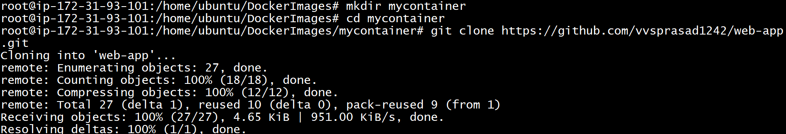**Install maven ,clone repository from github and build**

